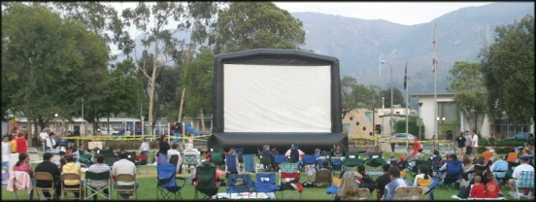

Blimp Screen Price List 011/05

Blimps Screens
w/Perforated Screen Surface, blower (1.5 HP),
tethers, bags, stakes, repair kit & mallet. All sizes are actual visible screen size.
16.5x30 ft BigBoyBlimp $9,695 Special Order – 2 weeks
18x24 XB (Xtra Beefy) $8,395 In Stock - Winter Special $7995
13.5 x 24 ft (HDTV) $8,395
15 ft x 20 ft $7,395 In Stock – Winter Special $6995
11.5 ft x 20 ft (HDTV) $7,395
11.25 ft x 15 ft $5,295
7.5 ft x 10 ft $4,295 In Stock
Baby Blimp (6x8 ft ) $2,795

Additional Items
Additional Screen Surface $695
Rear Blackout Drape $495
Hi Pressure Blower (1.5HP) $495
Road Case w/wheels $695
Work lights w/stand (2 sets) $149
Heavy Duty Steel Tent Pegs $12
Sledge mallet – 4 lb $25
Followspot – 1000 watt $959
LCD Projectors
PLC-XP51 - 4000 Lumen $5,995
PLC-XP55 - 4500 Lumen $7,295
LX 500 - 4000 Lumen $4,595
LX 400 – 3600 Lumen $3,795
PLC – 2000 Lumen (For 7x10 & 6x8) $1,995

Video Mixer $1,195
Sound System
DB Technologies OPERA Lyric
550 watt 15" 2way spkrs
2 Powered Speakers w/tripod stands and
mixer - incl 1 mic and audio cables $1,995
2 additional speakers on stands $1,700
BBB – FM Transmitter System $1,995
Speaker bags $59.95

Complete Movie in the Park Package
15x20 System
Pair of 550 watt powered DB Technologies
speakers on stands, audio cables,
microphone and audio mixer
Sanyo 4100 lumen LCD projector $14,695

Rental Packages
15 x 20 Screen only $750
Shipping cost (To You) $150 (approx)

Full package with sound, video, DJ,
Delivery, install etc
(Travel additional) $2,500

www. Blimpscreen.com - (818) 557 0903 – Email Mark@t2k.com

